**Deliverable 1**

**Section 1:**

**Project Title:** Hospital Management System

**Group Name:** Group 7

**Group Members:**

1. Nimmagadda Yogesh
2. Naga Sai Teja Chintakayala
3. Manoj Kumar Thimapuram
4. Maulshree Verma

**Section 2:**

**Project Description:** Hospital Management System is a web based project in which we try to implement the process in a hospital. The project comprises of four modules namely:

1. **Admin Module:** This module is the main module of the hospital management system. The major functionality of this module is to enter the details of any new employee in the database and generating its user-id and password. The admin can also soft-delete the records of the employee in-case the employee leaves the hospital.
2. **Front Desk User:** This module has the below mentioned functionalities:
3. Enter the records of the patient and generate its user-id and password
4. Schedule the appointment of the patient by checking the availability of the doctor
5. Accept payment from the patients and update it in the system
6. **Doctor:** The doctor can update his availability for two weeks later than the current date and check his scheduled appointments and patients.
7. **Patient:** Patient can check the appointments scheduled and can also rate the doctor based on his treatment.

**Language Used**: To create the system we will be using the below mentioned tools and technologies:

Asp.Net, C#, MySQL, HTML, CSS

**Platform**: Visual Studios 17, SQL Server Management Studio

The structure of the project can be understood from the below diagram: Figure 1 shows the webpages of the project and the links they contain for implementation of each module.

**Login page**

**Home Page**

**Doctor**

**Patient**

**Front Desk User**

**Admin**

Figure 1

**Project functionality overview:**

Given below is the overview of the processes that will be implemented in our project.

Figure 2 given below shows what is the relationship between different modules are what functionalities are being implemented in the project.

Figure

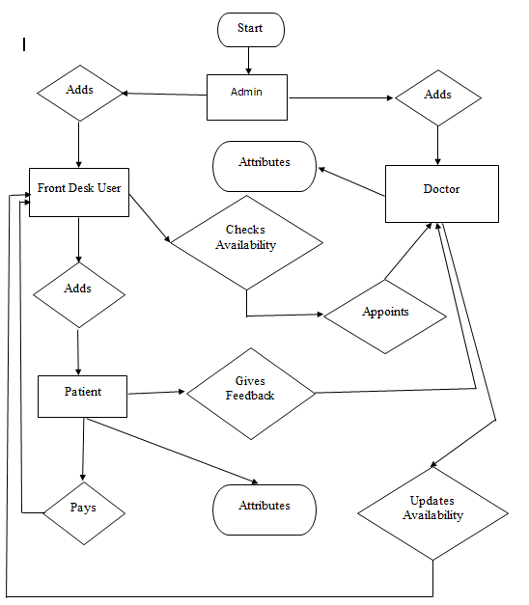

**Section 5:**

**Minutes of the Meeting:** Given below are the Minutes of the meetings for the four meeting done:

**Minutes of the meeting 1 (August 29, 2019):** The Project idea and the technology used was discussed and finalized.

**Minutes of the meeting 2** (September 3, 2019): The below points were discussed in the meeting:

1. Creating git-hub repository

2. What are the functionalities we would like to implement in our project

3. What are the modules we would be implementing in the project

**Minutes of the meeting 3 (September 5, 2019):** The below points were discussed in the meeting:

1. Software installation for the project

2. List of web pages need to be created

3. List of tables required for the project

**Minutes of the meeting 4 (September 9, 2019)**

1. Roles were assigned to each team member

2. Deliverable 1 was discussed.

3. Design for login page was discussed and done.

4. Tables were created.

**Section 6:**

**Gantt chart:**

The Figure 3 and Figure 4 below depict the Gantt chart for implementing the project along with the deliverables of the project.

Figure

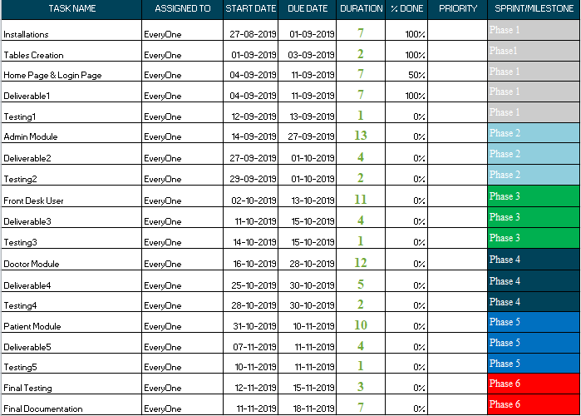

Figure

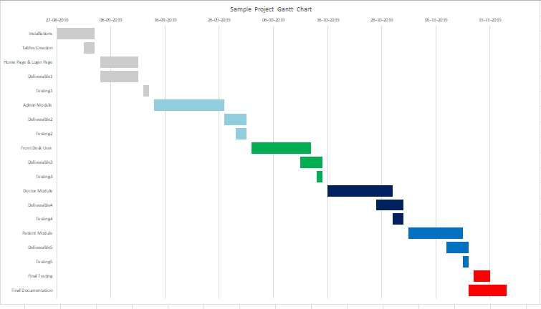

**Section 7:**

**Risk Management:**

The 3 major risks involved in this project are:

1. **Software Incompatibility:** This risk is because the programming language being used requires an older version, which may not be compatible with the laptops. Along with this, there might be risk in using the certain coding techniques such as try-catch block and finally for exception handling, etc. Such coding techniques may not be compatible with the software being used
2. **Security risks:** There are numerous security risks in our project such as unauthorized access to admin login page or getting the access to front desk user where the attacker can modify the information as per his requirements
3. **Technical feasibility:** There is a risk in the project that all the functionalities listed might not be technically feasible to code, and therefore, could not be implemented.

The above risks can be mitigated with time by following the below mentioned steps:

1. **Feasibility analysis:** Analysing the feasibility of functionalities, and understanding how these functionalities can be implemented can help us in reducing this risk. Also, by doing feasibility analysis we can enhance the performance and add more functionalities in our project.
2. Adding security features such as hashing the passwords and adding sessions in login will help in reducing the risks of security breaches.
3. Updating the software in the laptop, proper planning of the project, using the latest coding techniques and proper testing can help in reducing the risks of software incompatibility.

**Section 8:**

**Roles Assigned to team members:**

**Front Desk User and Back end user- Maulshree Verma**:

* Responsible for developing the front desk user module,
* Also responsible for database connectivity and CRUD operations.

**Admin Module and documentation- Naga Sai Teja Chintakayala**

* Responsible for documentation
* Responsible for developing the admin module.

**Doctors Module and Login Page- Manoj Kumar Thimapuram**

* Responsible for adding the tables in the Database,
* Responsible for creating the login page
* Responsible for developing the admin module.

**Patients Module and Home Page and Sessions- Yogesh Nimmagadda**

* Responsible for creating the home page,
* Responsible for developing the Patient module
* Responsible for writing code for user session management.